**Hello World RESTful Web Service**   
  
Write a REST service in the spring learn application created earlier, that returns the text "Hello World!!" using Spring Web Framework. Refer details below:  
  
**Method:** GET  
**URL:** /hello  
**Controller:** com.cognizant.spring-learn.controller.HelloController  
**Method Signature:** public String sayHello()  
**Method Implementation:** return hard coded string "Hello World!!"  
**Sample Request**: http://localhost:8083/hello  
**Sample Response:** Hello World!!   
  
**IMPORTANT NOTE**: Don't forget to include start and end log in the sayHello() method.  
  
Try the URL http://localhost:8083/hello in both chrome browser and postman.  
  
SME to explain the following aspects:

* In network tab of developer tools show the HTTP header details received
* In postman click on "Headers" tab to view the HTTP header details received

**HelloController.java:** 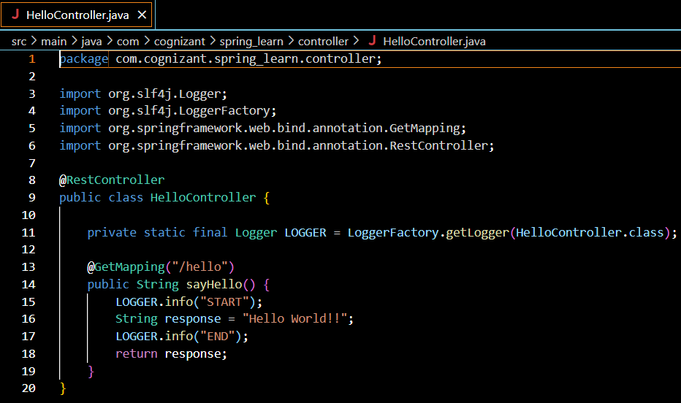

**SpringLearnApplication.java:**

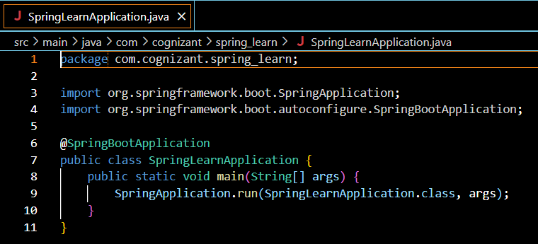

**Application.properties:**

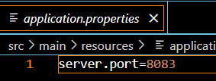

**Pom.xml**

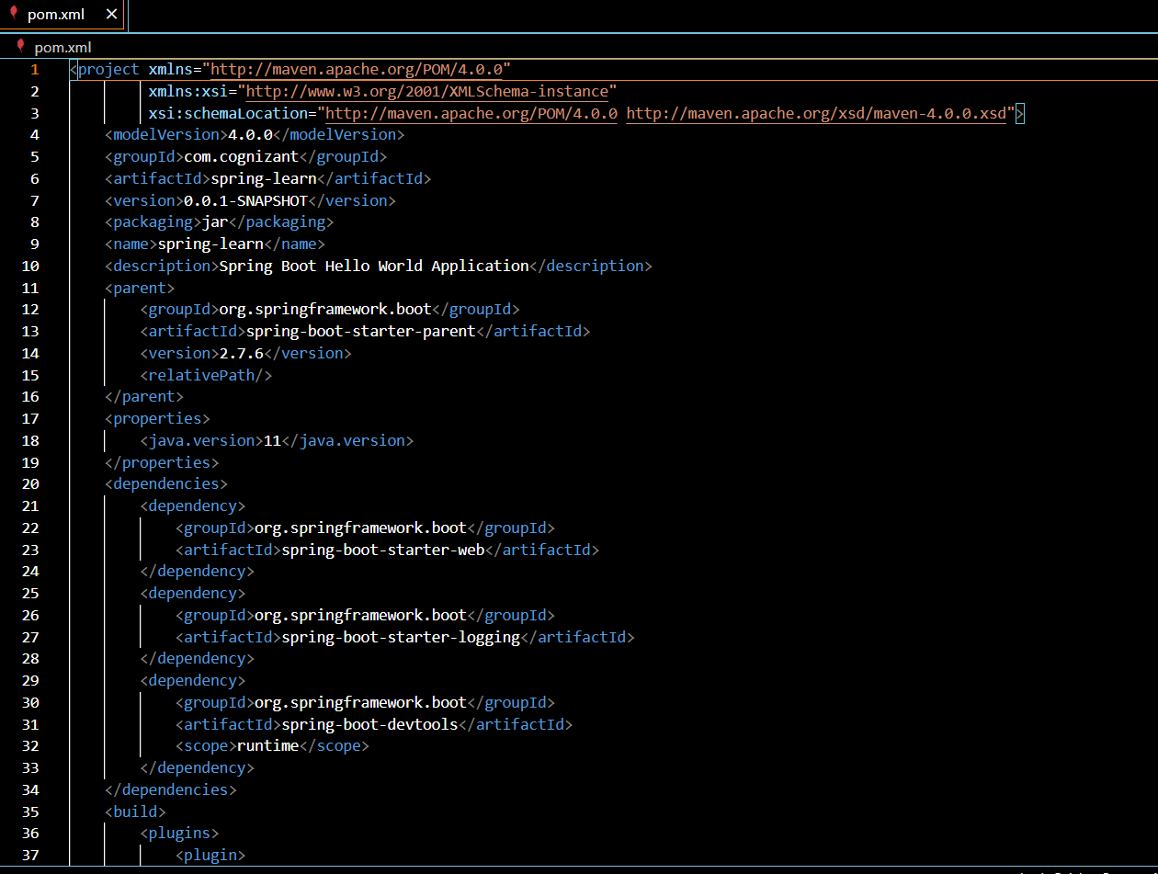

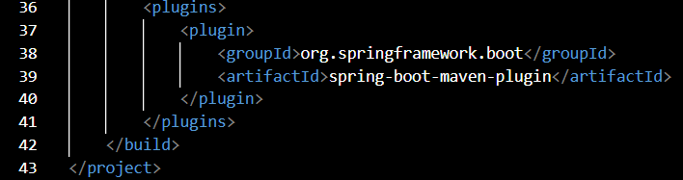

**Output:**



**REST - Country Web Service**   
  
Write a REST service that returns India country details in the earlier created spring learn application.  
  
**URL**: /country  
**Controller**: com.cognizant.spring-learn.controller.CountryController  
**Method Annotation**: @RequestMapping  
**Method Name**: getCountryIndia()  
**Method Implementation**: Load India bean from spring xml configuration and return  
**Sample Request**: http://localhost:8083/country  
**Sample Response**:

{

  "code": "IN",

  "name": "India"

}

SME to explain the following aspects:

* What happens in the controller method?
* How the bean is converted into JSON reponse?
* In network tab of developer tools show the HTTP header details received
* In postman click on "Headers" tab to view the HTTP header details received

**Country.java:**

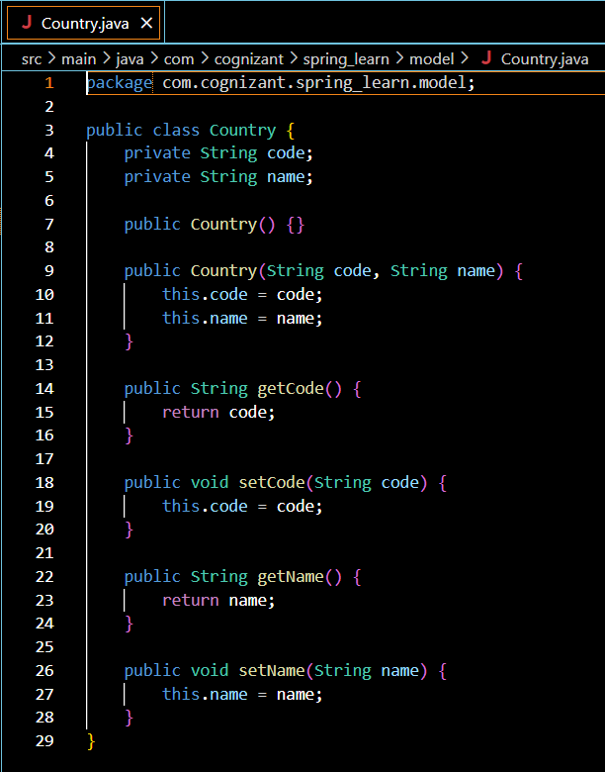

**CountryController.java:**

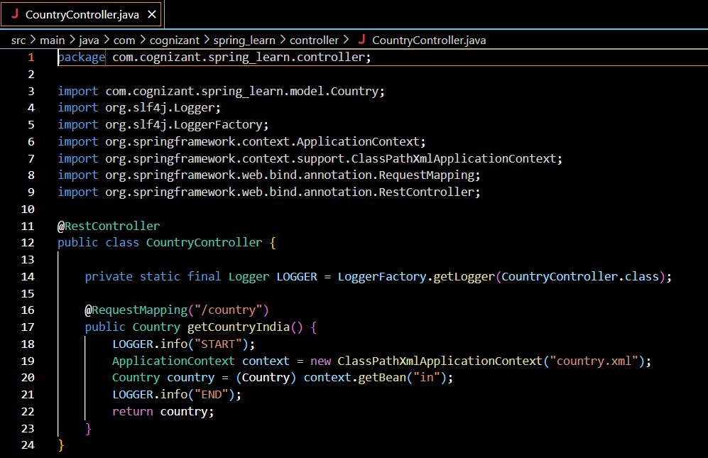



**SpringApplication.java:**

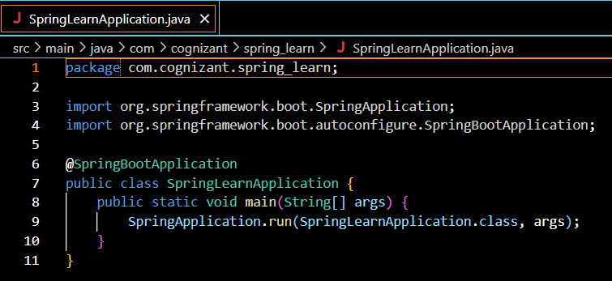

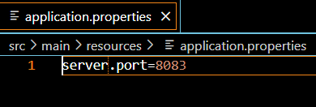**Applicationproperties.java**

**Country.xml**

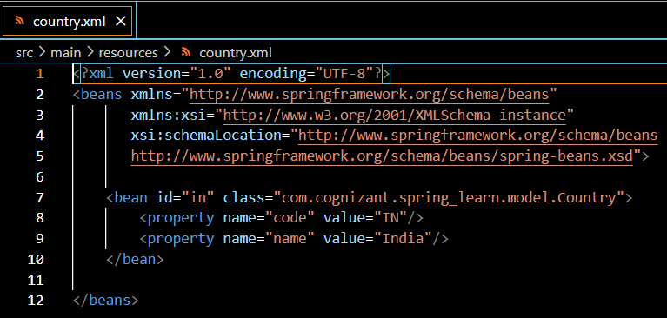

**Pom.xml:**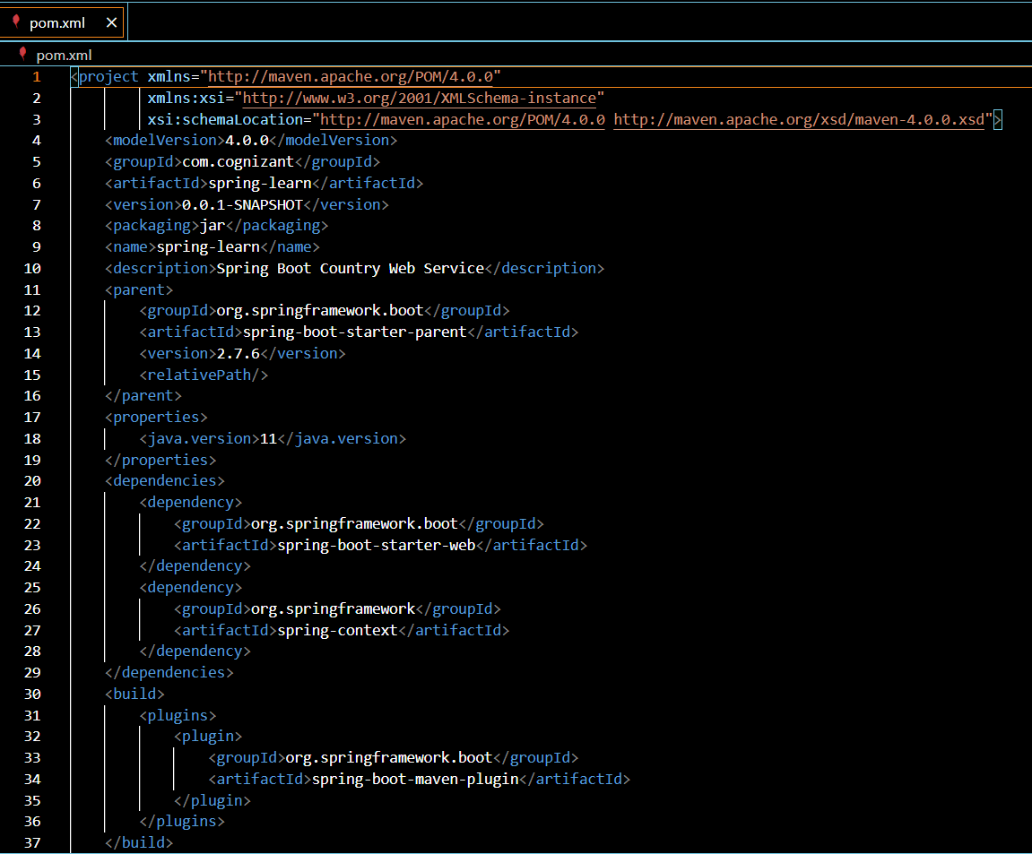

**Output:**

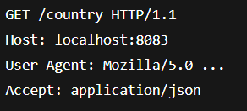

**REST - Get country based on country code**   
  
Write a REST service that returns a specific country based on country code. The country code should be case insensitive.  
  
**Controller**: com.cognizant.spring-learn.controller.CountryController  
**Method Annotation:** @GetMapping("/countries/{code}")  
**Method Name**: getCountry(String code)  
**Method Implemetation**: Invoke countryService.getCountry(code)   
**Service Method:**com.cognizant.spring-learn.service.CountryService.getCountry(String code)  
  
**Service Method Implementation**:

* Get the country code using @PathVariable
* Get country list from country.xml
* Iterate through the country list
* Make a case insensitive matching of country code and return the country.
* Lambda expression can also be used instead of iterating the country list

**Sample Request**: http://localhost:8083/country/in  
  
**Sample Response**:

{

  "code": "IN",

  "name": "India"

}

**CountryController.java:**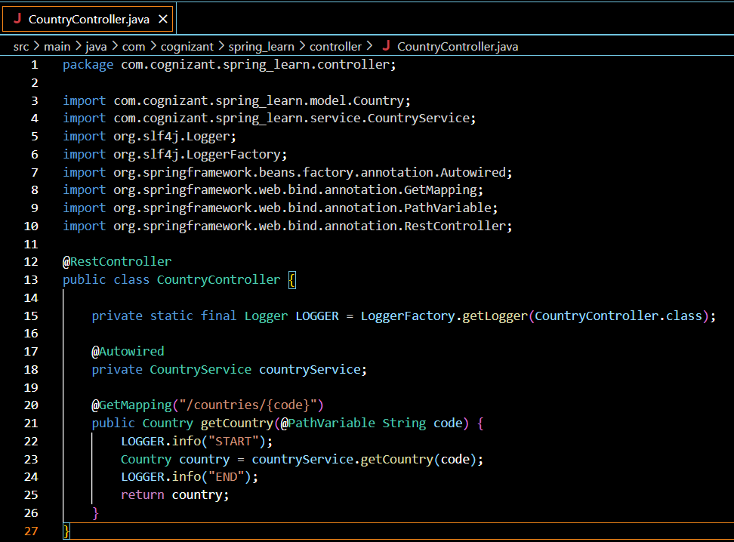

**Country.java**

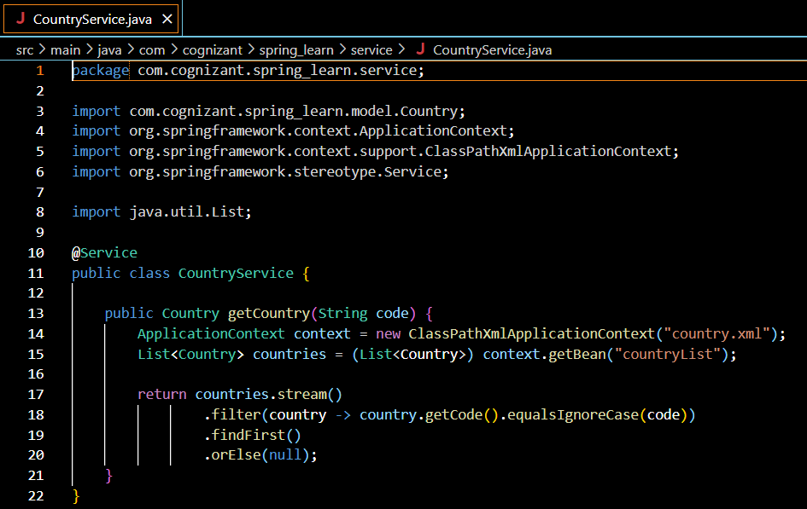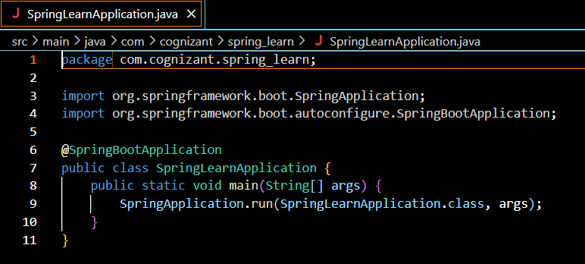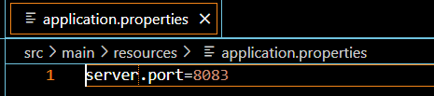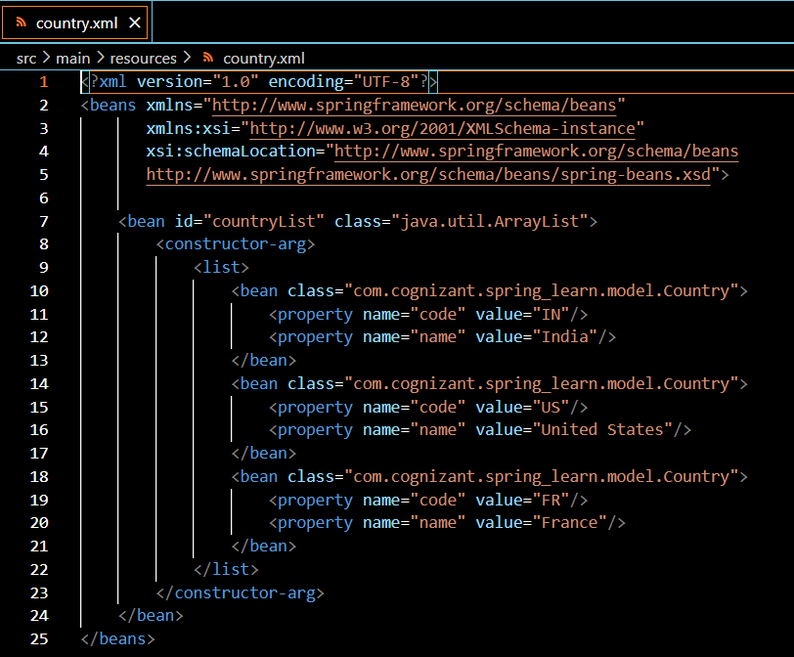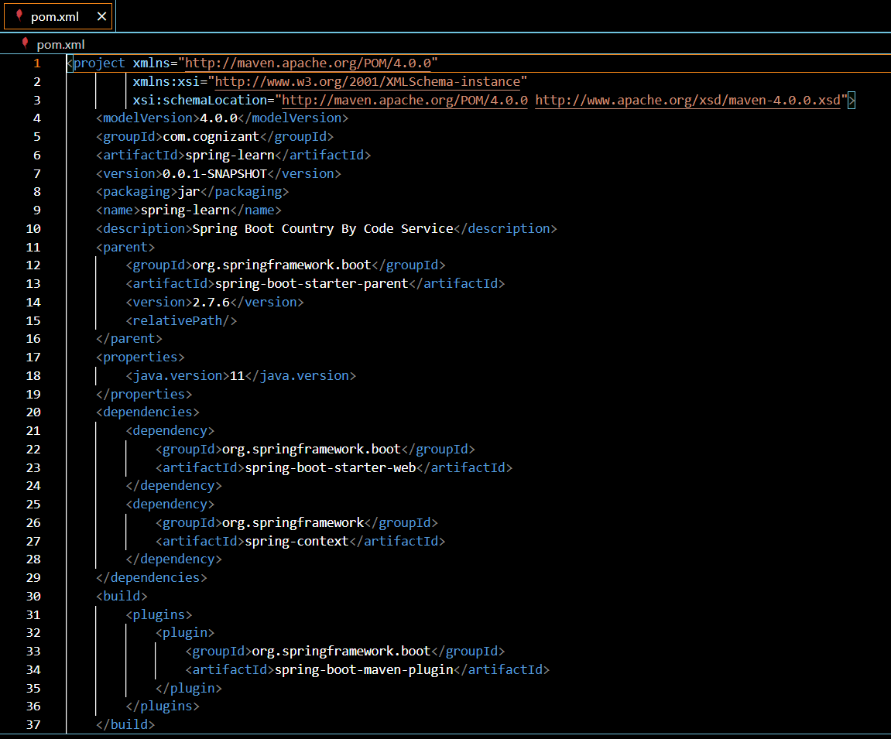

**Output:**

